**Nguyen Duc Thinh**

Supervisor: **Doan Trung Tung**

April 2016

**An investigation about Hybrid Mobile Application Development to develop a Matrimonial Android Application**

Word count: **100000**

Product and Development files:

Please choose one and delete the rest

1. Uploaded as a zip file
2. Copied to the P drive (having arranged this in advance cps@gre.ac.uk)
3. Handed into the school office with the header sheet.

A dissertation submitted in partial fulfilment of the University of Greenwich’s

**Tiny Matrimony**

Abstract

Nowadays, smartphones have become one of the most essential things for many people. By using smartphones, people can do many tasks from remote, fast and easy. With the rise of smartphones, people now can connect to the internet from everywhere. People will want to keep contact and communicate with others any time from their smartphones because they can bring them to everywhere and can easily connect to the internet. This project will investigate about the rise of smartphones and its applications, the trends and opportunities in developing smartphone applications, and explain the development process for a matrimony application. By using this app, people can make new friends, communicate with others, stores profiles, etc.

Preface

.

Finding a mate is a very important job of anyone. From immemorial time, people has many ways to find a wife, or their husband. They participated in festivals, clubs, or they can be found right in their class but most are limited by the geographical distance. Today, with the rapidly growing of the internet and smartphones, anyone can owning a smartphone, people can interact with your friends, make new acquaintances and make new friends, etc.. So use your own smartphone to find a mate for yourself is entirely possible.

Acknowledgements

I want especially thanks to my supervisor Doan Trung Tung, who gave me advice to the project could be completed.

Sincerely thank!

Contents

Table of Contents

Abstract ii

Preface iii

Acknowledgements iv

Contents iv

1 Introduction 4

1.1 Background information 4

1.2 Project aims and objectives 4

2 Literature Review 4

2.1 Introduction 4

2.2 Mobile application development 4

2.2.1 Hybrid and Native mobile application 4

2.2.2 Native or Hybrid application? 4

2.3 Key issues to use in the design and implementation 4

2.4 Conclusion 4

3 Review of exists matrimony system 4

3.1 Introduction 4

3.2 Product 1 4

3.2.1 Overview 4

3.2.2 Appearance 4

3.2.3 Usability 4

3.3 Product 2 4

3.4 Product 3 4

3.5 Key issues to use in the design and implementation 4

3.6 Conclusions 4

4 Requirements Analysis 4

5 Design of Tiny Matrimony System 4

5.1 Introduction 4

5.2 Use Case 4

5.3 Navigational Structure 4

5.4 Entity Relationship Diagram 4

5.5 Database Implement 4

5.6 Schema 4

5.6.1 Account_TBL 4

5.6.2 Information_TBL 4

5.6.3 Family_TBL 4

5.6.4 Profile_TBL 4

5.6.5 Hobby_TBL 4

5.6.6 Hobby_Mapping_TBL 4

5.6.7 Hobby_Catalog_TBL 4

5.6.8 Hobby_Catalog_Mapping_TBL 4

5.6.9 UserImage_TBL 4

5.6.10 Survey_TBL 4

5.6.11 Friends 4

5.6.12 Message_TBL 4

5.6.13 Message_Mapping_TBL 4

5.7 Detail Functional Design 4

5.7.1 Introduction 4

5.7.2 Register 4

5.7.3 Reset password 4

5.7.4 Login 4

5.7.5 Change password 4

5.7.6 Active account 4

5.7.7 Resend active code 4

5.7.8 Enter information 4

5.7.9 Enter matching survey 4

5.7.10 Upload avatar 4

5.7.11 View avatar 4

5.7.12 Edit avatar 4

5.7.13 View cover image 4

5.7.14 Edit cover image 4

5.7.15 Upload their image 4

5.7.16 View their image in gallery 4

5.7.17 View profile 4

5.7.18 Edit user information 4

5.7.19 Edit matching survey 4

5.7.20 View matching result 4

5.7.21 View other profile 4

5.7.22 Send friend request to user 4

5.7.23 View friend request list 4

5.7.24 Cancel friend request 4

5.7.25 View list friend request of user 4

5.7.26 Decide friend request 4

5.7.27 Accept friend request 4

5.7.28 Unfriend 4

5.7.29 View friend list 4

5.7.30 Search 4

5.7.31 View gallery of other user 4

5.7.32 Chat 4

5.7.33 Logout 4

6 Development of……….. 4

7 Testing and Evaluation 4

7.1 Introduction 4

7.2 Function Testing 4

7.2.1 User function 4

7.2.2 System function 4

7.3 UI testing 4

7.3.1 Responsive testing: 4

7.3.2 Componence Testing 4

7.4 Evaluation 4

7.5 Conclusion 4

References 4

Appendix A - Project Proposal 4

Appendix B - ??????? 4

Appendix C - ??????? 4

# Introduction

## Background information

In these days, the busy life is about to take away almost time of human, it makes our relationships fewer and makes the distance between people to people further and further. Instead of happy moments beside our families or friends, we choose works and works. People now can spend whole day, even whole week on working, with deadline and projects, but we can’t give time to have meals with friends or relationships. We can continuously look for partners in business every day, every month to make profit for our company, but we can’t take one hour to find some new friends. Nothing but busy life make human not have any time to look for friends and make a date. So what is the solution for our recent society? To make the distance between people to people closer, to make the great relationships bear in recent day even when people try to work for our society?

We need a tool to help looking for relationships or talking to each other even when we are busy the most. And Matrimony System, which can help people to communicate with many people in many place is the answer for the question above. Being born of Matrimony System is like the rescuing the good things and permanent things in this society. Even though being too busy, human still find each other through this system. This is effective way to make the distance between people to people closer and create the permanent relationships. With all things above, we can see that Matrimony System is extremely necessary. And nowadays, almost people use smartphones. Few years ago, smartphones were is very expensive. But now they have become common devices and anyone can have one with powerful performance. Smartphone being more smart, it can replace a laptop and can do everything an laptop can do, and with lightweight, small so people can bring them to anywhere, it's very useful. Therefore, building this system into the mobile application will have highest efficiency.

## Project aims and objectives

The main aim of this project is to develop a mobile application allowing users to easily find and communicate with other people, who may suit with them based on their information and their individual searching criteria.

These are the main objectives of this project:

- Research about matrimonial system.

- Investigate about mobile applications development.

- Select the development solutions appropriate with system.

- Building and complete the system.

- Evaluate the system after finishing.

# Literature Review

## Introduction

Matrimony system is a system almost like the online dating website, users can upload their profile including basic information, about education or their career to the system. Then with that information system will looking and gives for user list of people who may suit with them and their criteria. In addition users can search based on other criteria such as age, residence, education level or occupation. Such systems usually found a lot in India, but with other countries, or particular Vietnam, such system is not really popular and little people know that. Along with the growth of internet, the demand for online matrimony looking is growing rapidly due to its advantages such as fast and easy. Therefore developing a similar system in Vietnam will have a high chance of success and will open more opportunities for people to look for people who are suit for them. Most current matrimony systems are website, users always need access to websites to use. But now mobile applications are flourished, so developing a new system on mobile matrimony more reasonable than develop a website. And this system named Tiny Matrimony.

## Mobile application development

### Hybrid and Native mobile application

Currently the smartphone is very developed with a lot of mobile the operating system like Android, iOS, Windows Phone, etc. Each mobile platform offers developers their own development tools, interface elements and their SDK. To develop a mobile app, people often use for language correspondent for the operating system, such as Java for Android, Objective C for iOS and more recently with iOS Swift, etc. These application were developed upon a specific programming language, can’t work on other operating systems is called the native application. Besides native application, there are also have hybrid application. Basically, a hybrid application is a web apps built using HTML5 and JavaScript, wrapped in a native container which loads most of the information on the page as the user navigates through the application. It's a cross the between native application vs web application. Hybrid application are written in the same languages used to write web apps and can be deployed across multiple platforms easily.

### Native or Hybrid application?

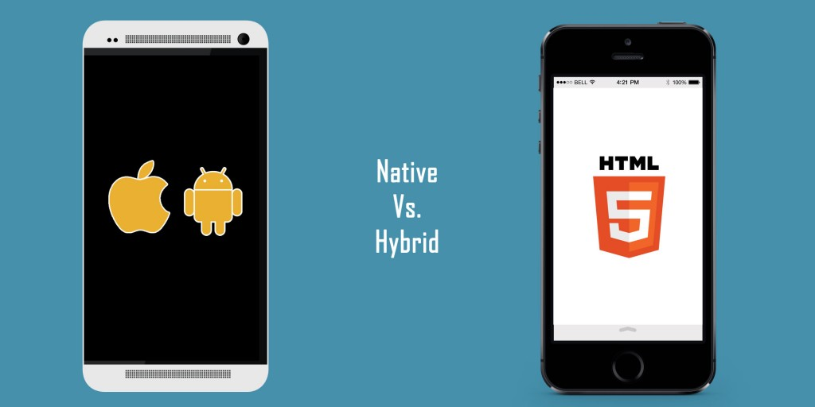

Native or Hybrid application have their advantages.

## Key issues to use in the design and implementation

## Conclusion

# Review of existing matrimony system

## Introduction

## Product 1

Review product. Use some appropriate level 3 headings for each product, for example:

### Overview

### Appearance

### Usability

## Product 2

## Product 3

## Key issues to use in the design and implementation

## Conclusions

# Requirements Analysis

Results of surveys

Results of interviews etc

What did you decide to create based on this?

Functional specification.

# Design of Tiny Matrimony System

## Introduction

This part talk about design progress of this system, is contained: use case, Entity Relationship Diagram, Implement ERD to database and detail of functional design.

## Use Case

The use case describes the interaction between the user (Actor) and the system. It also describes the requirements for the system, what the system will do.

Use case diagram of Tiny Matrimony system:

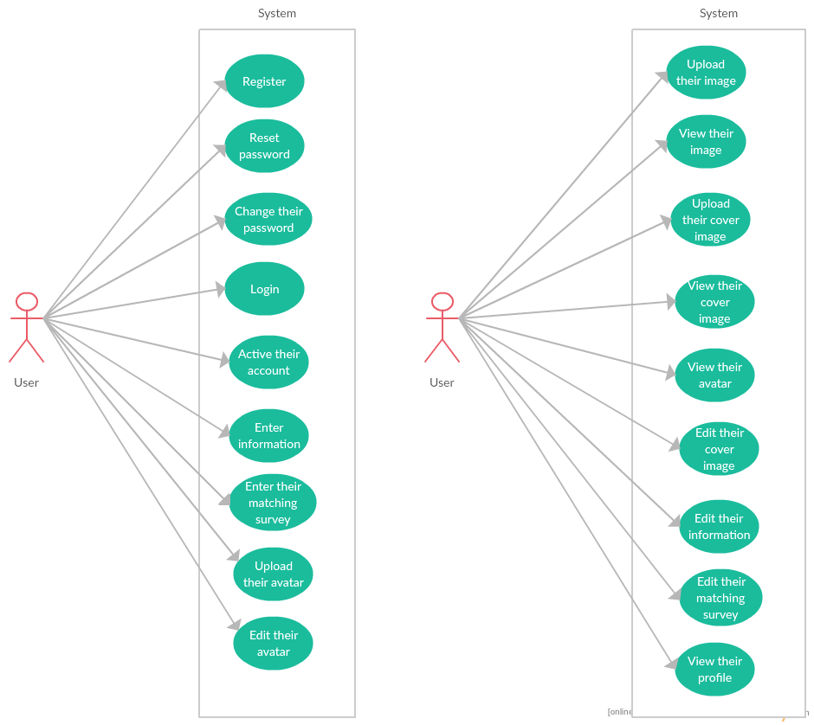

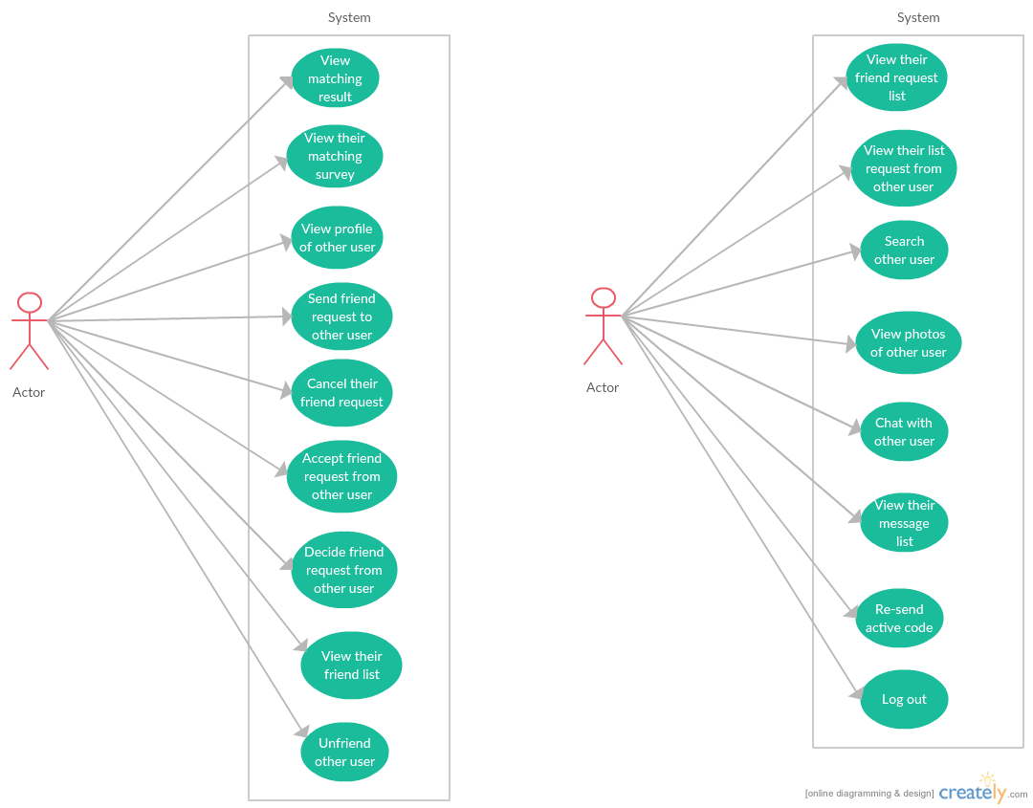

## Navigational Structure

This part contain navigation structure. It helps us to get a general view about the system, the structure between the components and have a clearer visualization workflow of the system.

Navigational of Tiny Matrimony System:

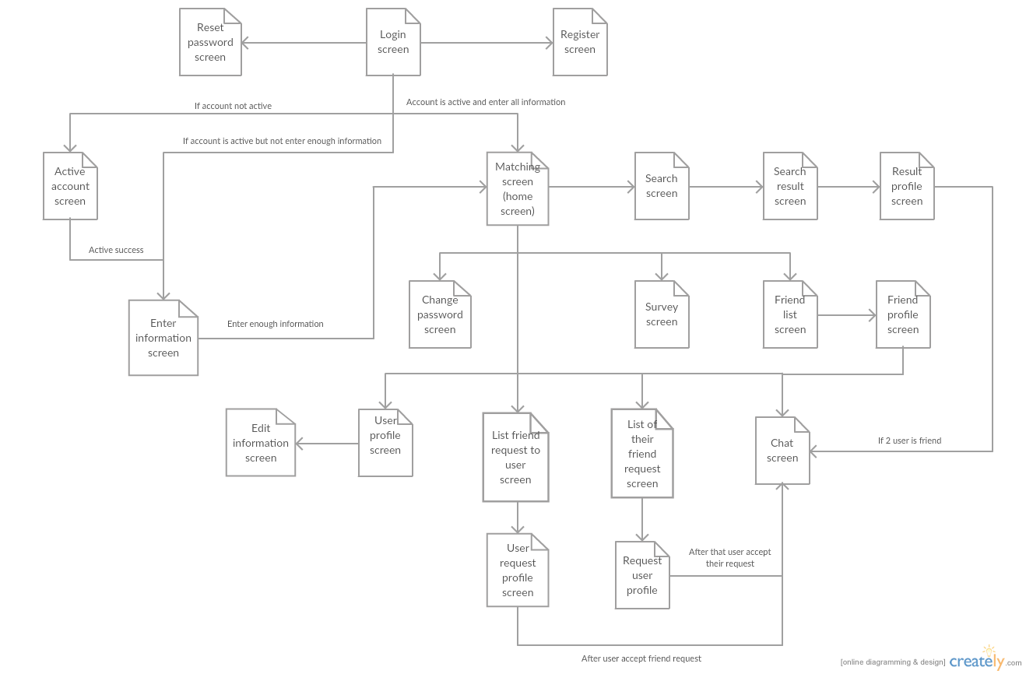

## Entity Relationship Diagram

This part is show ERD of Tiny Matrimony System include all entities with their Primary Key.

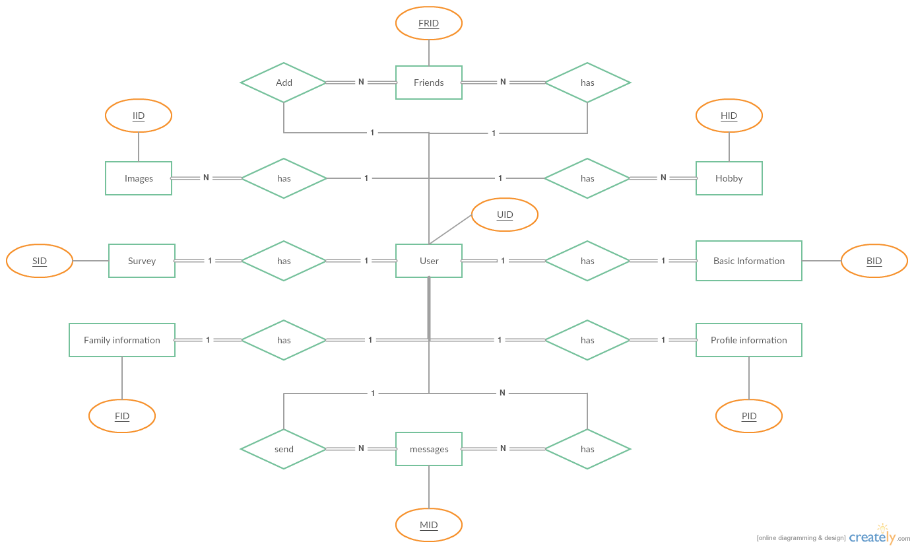

## Database Implement

This part contain diagram of database after implement from ERD.

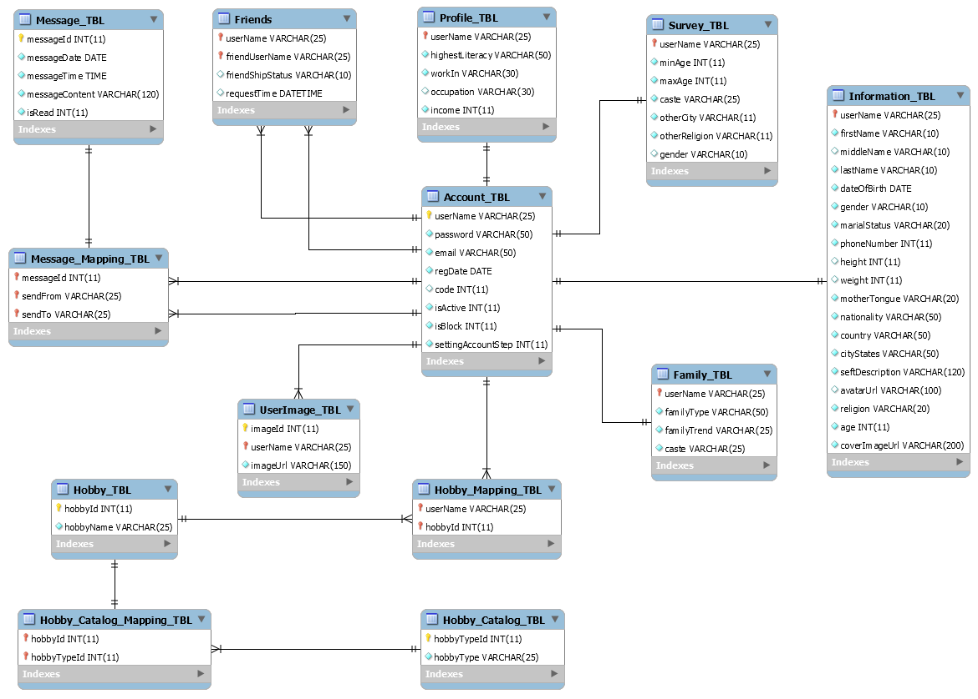

## Schema

Set object in the database of Tiny Matrimony System

|  |  |  |
| --- | --- | --- |
| # | Name | Description |
| 1 | Account_TBL | List all account in the system |
| 2 | Information_TBL | Contain basic information about user |
| 3 | Family_TBL | Contain information about family of user |
| 4 | Profile_TBL | Contain information about education and work of user |
| 5 | Hobby_TBL | List of all name of hobby in system |
| 6 | Hobby_Mapping_TBL | Mapping hobby name with user |
| 7 | Hobby_Catalog_TBL | List of all catalog of hobby in system |
| 8 | Hobby_Catalog_Mapping_TBL | Mapping hobby name with their catalog |
| 9 | UserImage_TBL | List all user image |
| 10 | Survey_TBL | Contain matching survey of user |
| 11 | Friends | Contain all friends, friend request of user |
| 12 | Message_TBL | List all message on system |
| 13 | Message_Mapping_TBL | Mapping message to user |

### Account_TBL

|  |  |  |  |
| --- | --- | --- | --- |
| **Account_TBL** | | | |
| # | Column name | Type | Description |
| 1 | userName | VARCHAR | PK, not null. unique |
| 2 | password | VARCHAR | Not null, password for user’s account |
| 3 | email | VARCHAR | Not null, email of user |
| 4 | regDate | DATE | Not null, date account registed |
| 5 | code | INT | Code for user to active account |
| 6 | isActive | INT | 1: Account is active 0: Account not active  Default: 0 |
| 7 | isBlock | INT | 1: Account is blocked 0: Account not block  Default: 0 |
| 8 | settingAccountStep | INT | Save step for enter information of user after register and active account Default: 1 |

### Information_TBL

|  |  |  |  |
| --- | --- | --- | --- |
| **Information_TBL** | | | |
| # | Column name | Type | Description |
| 1 | userName | VARCHAR | PK, FK to Account_TBL, not null, unique |
| 2 | firstName | VARCHAR | Not null |
| 3 | middleName | VARCHAR |  |
| 4 | lastName | VARCHAR | Not null |
| 5 | dateOfBirth | DATE | Not null |
| 6 | gender | VARCHAR | Not null |
| 7 | marialStatus | VARCHAR | Not null |
| 8 | phoneNumber | INT | Not null, phone number of user |
| 9 | height | INT | Not null, height of user |
| 10 | weight | INT | Not null, weight of user |
| 11 | motherTongue | VARCHAR | Not null, mother tongue of user |
| 12 | nationality | VARCHAR | Not null, nationality of uer |
| 13 | country | VARCHAR | Not null, country user live |
| 14 | cityStates | VARCHAR | Not null, city user live |
| 15 | seftDescription | VARCHAR | Not null, introduction of user |
| 16 | avatarUrl | VARCHAR | Not null, link to avatar of user |
| 17 | religion | VARCHAR | Not null, religion of user |
| 18 | age | INT | Not null, age of user |
| 19 | coverImageUrl | VARCHAR | Not null, link to cover image of user |

### Family_TBL

|  |  |  |  |
| --- | --- | --- | --- |
| **Family_TBL** | | | |
| # | Column name | Type | Description |
| 1 | userName | VARCHAR | PK, FK to Account_TBL, not null, unique |
| 2 | familyType | VARCHAR | Not null, type of user’s family |
| 3 | familyTrend | VARCHAR | Not null, trend of user’s family |
| 4 | caste | VARCHAR | Not null, caste of user’s family |

### Profile_TBL

|  |  |  |  |
| --- | --- | --- | --- |
| **Profile_TBL** | | | |
| # | Column name | Type | Description |
| 1 | userName | VARCHAR | PK, FK to Account_TBL, not null, unique |
| 2 | highestLiteracy | VARCHAR | Not null, highest literacy of user |
| 3 | workIn | VARCHAR | Not null, type of company user work for |
| 4 | occupation | VARCHAR | Not null, occupation of user |
| 5 | income | INT | Not null, contain monthly income of user |

### Hobby_TBL

|  |  |  |  |
| --- | --- | --- | --- |
| **Hobby_TBL** | | | |
| # | Column name | Type | Description |
| 1 | hobbyId | INT | PK, Not null, unique, auto increment |
| 2 | hobbyName | VARCHAR | Not null, name of hobby |

### Hobby_Mapping_TBL

|  |  |  |  |
| --- | --- | --- | --- |
| **Hobby_Mapping_TBL** | | | |
| # | Column name | Type | Description |
| 1 | userName | VARCHAR | PK, FK to Account_TBL, not null |
| 2 | hobbyName | VARCHAR | PK, FK to Account_TBL, not null |

### Hobby_Catalog_TBL

|  |  |  |  |
| --- | --- | --- | --- |
| **Hobby_Catalog_TBL** | | | |
| # | Column name | Type | Description |
| 1 | hobbyTypeId | INT | PK, Not null, unique, auto increment |
| 2 | hobbyType | VARCHAR | Not null, name of hobby type |

### Hobby_Catalog_Mapping_TBL

|  |  |  |  |
| --- | --- | --- | --- |
| **Hobby_Catalog_Mapping_TBL** | | | |
| # | Column name | Type | Description |
| 1 | hobbyId | INT | PK, FK to Hobby_TBL, not null |
| 2 | hobbyTypeID | INT | PK, FK to Hobby_Catalog_TBL, not null |

### UserImage_TBL

|  |  |  |  |
| --- | --- | --- | --- |
| **UserImage_TBL** | | | |
| # | Column name | Type | Description |
| 1 | imageID | INT | PK, Not null, unique, auto increment |
| 2 | userName | VARCHAR | FK to Account_TBL, not null |
| 3 | imageUrl | VARCHAR | Not null, link to this image |

### Survey_TBL

|  |  |  |  |
| --- | --- | --- | --- |
| **Survey_TBL** | | | |
| # | Column name | Type | Description |
| 1 | userName | VARCHAR | PK, FK to Account_TBL, not null, unique |
| 2 | minAge | INT | Not null, min age user want to match Default 16 |
| 3 | maxAge | INT | Not null, max age user want to match Default 80 |
| 4 | caste | VARCHAR | Not null, caste of user want to match |
| 5 | otherCity | VARCHAR | y: user want to match with people in other city n: user don’t want to match with people in other city Default: y |
| 6 | otherReligon | VARCHAR | y: user want to match with people in other religion n: user don’t want to match people in other religion Default: y |
| 7 | gender | VARCHAR | Not null, gender user want to match |

### Friends

|  |  |  |  |
| --- | --- | --- | --- |
| **Friends** | | | |
| # | Column name | Type | Description |
| 1 | userName | VARCHAR | PK, FK to Account_TBL, not null, unique |
| 2 | friendUserName | VARCHAR | PK, FK to Account_TBL, not null, unique |
| 3 | friendShipStatus | VARCHAR | Not null, status of friendship request: user are request friend: users are friend  Default: request |
| 4 | requestTime | DATETIME | Time of request |

### Message_TBL

|  |  |  |  |
| --- | --- | --- | --- |
| **Message_TBL** | | | |
| # | Column name | Type | Description |
| 1 | messageId | INT | PK, Not null, unique, auto increment |
| 2 | messageDate | DATE | Not null, date message send |
| 3 | messageTime | TIME | Not null, time message send |
| 4 | messageContent | VARCHAR | Not null, comtent of message |
| 5 | isRead | INT | 1: message is read 0: message not read Default: 0 |

### Message_Mapping_TBL

|  |  |  |  |
| --- | --- | --- | --- |
| **Message_Mapping_TBL** | | | |
| # | Column name | Type | Description |
| 1 | messageId | INT | PK, FK to Message_TBL |
| 2 | sendFrom | VARCHAR | PK, FK to Account_TBL, not null |
| 3 | sendTo | VARCHAR | PK, FK to Account_TBL, not null |

## Detail Functional Design

### Introduction

From use case, this section will describe detail about the functional of Tiny Matrimoy System and include: functional detail, workflow and screen design.

### Register

Functional detail:

|  |  |
| --- | --- |
| Name | Register |
| Description | User can register account to use this application |
| Actor | User |
| Pre-condition | User input username, email and password |
| Post-condition | Success: Show success message to user Fail: Show error message to user |

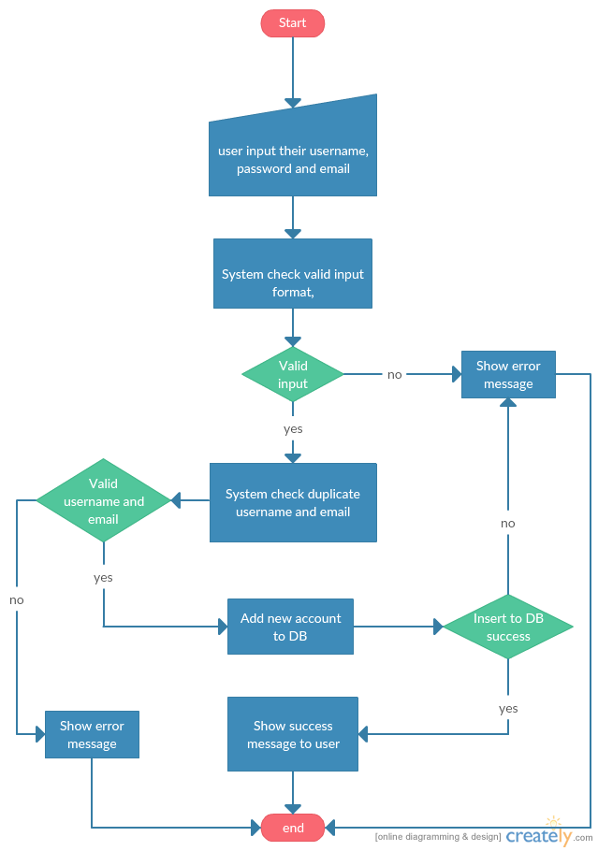Workflow:

Screen:

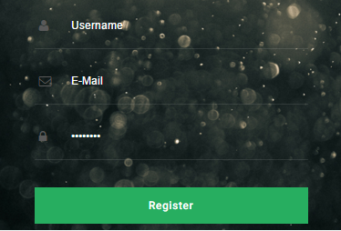

### Reset password

Functional detail:

|  |  |
| --- | --- |
| Name | Reset password |
| Description | User can reset their password if forgot |
| Actor | User |
| Pre-condition | User input their account’s email |
| Post-condition | Success: Show success message to user Fail: Show error message to user |

Workflow:

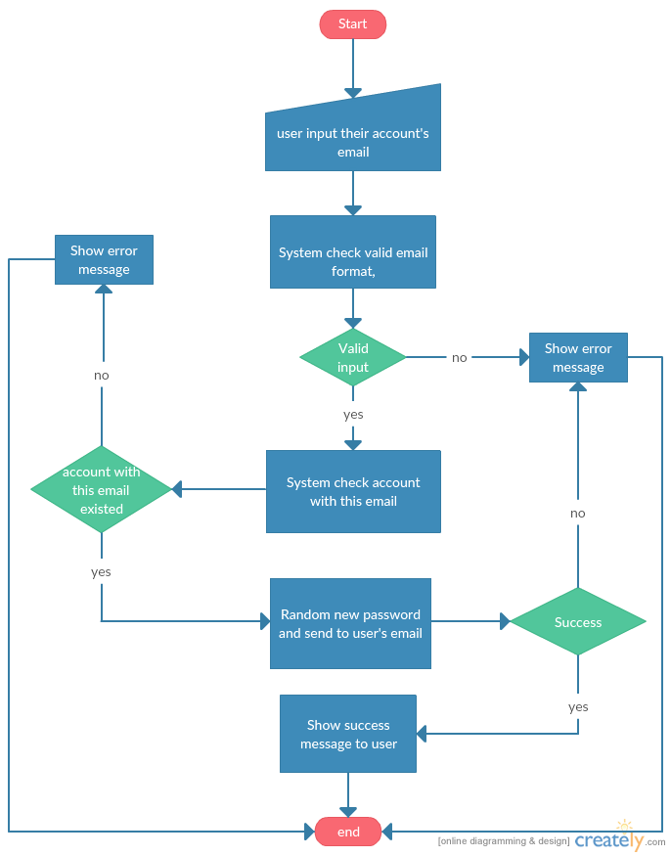

Screen:

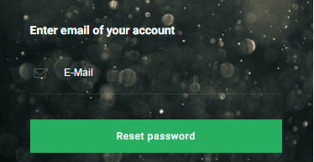

### Login

Functional detail:

|  |  |
| --- | --- |
| Name | Login |
| Description | User can login to system using their account |
| Actor | User |
| Pre-condition | User input their account and password |
| Post-condition | Success: Redirect to home screen Fail: Show error message to user |

Workflow:

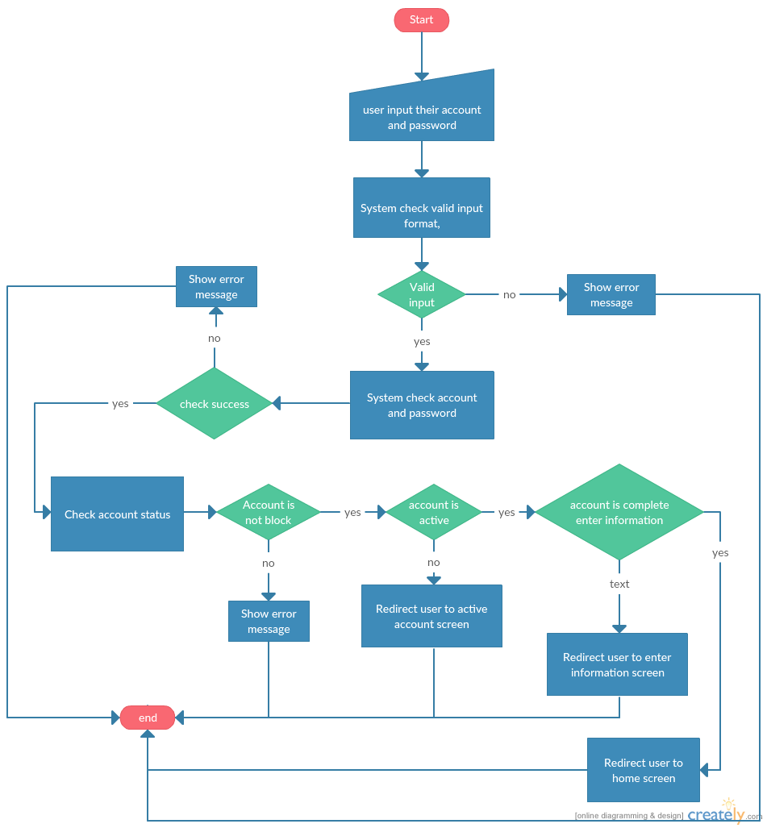

Screen:

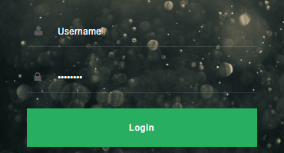

### Change password

Functional detail:

|  |  |
| --- | --- |
| Name | Change password |
| Description | User can change their password |
| Actor | User |
| Pre-condition | - User login success to system, account isn’t block, is active and complete enter information. - User enter their current password and new password |
| Post-condition | Success: Show success message to user Fail: Show error message to user |

Workflow:

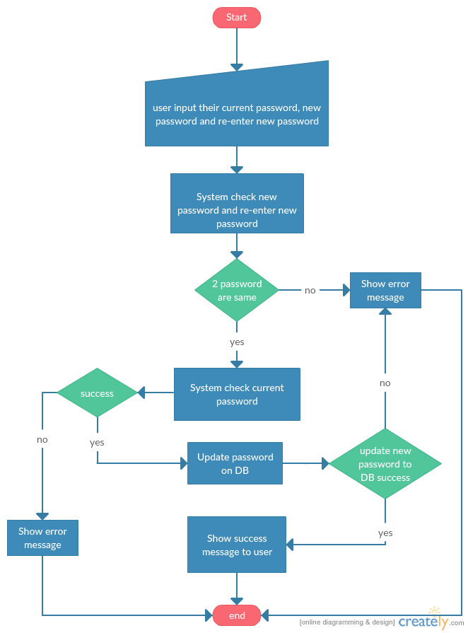

Screen:

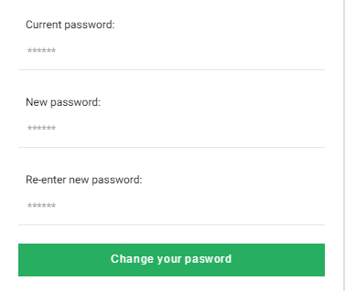

### Active account

Functional detail:

|  |  |
| --- | --- |
| Name | Active password |
| Description | User can active their account in first login |
| Actor | User |
| Pre-condition | - User login success to system, account isn’t active - User enter their active code receive from their email |
| Post-condition | Success: Show success message to user Fail: Show error message to user |

Workflow:

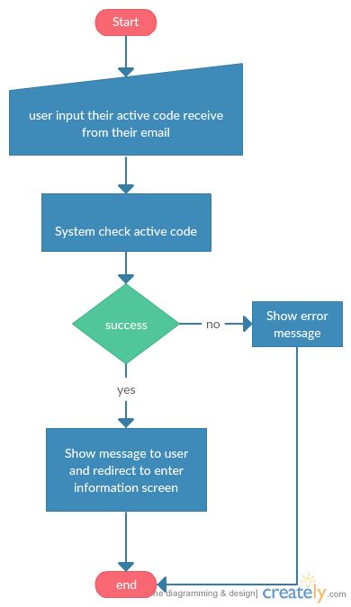

Screen:

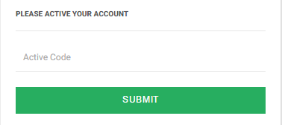

### Resend active code

Functional detail:

|  |  |
| --- | --- |
| Name | Resend active code |
| Description | User can resend their active code |
| Actor | User |
| Pre-condition | - User login success to system, account isn’t active - User press resend active code button |
| Post-condition | Success: Show success message to user, send new code to user’s email Fail: Show error message to user |

Workflow:

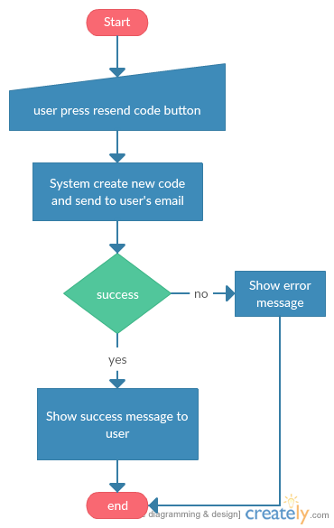

Screen:

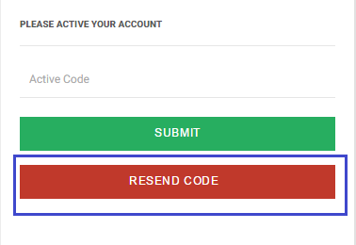

### Enter information

Functional detail:

|  |  |
| --- | --- |
| Name | Enter information |
| Description | User need enter all require information after active account to use other functions |
| Actor | User |
| Pre-condition | - User login success to system, account is active - User enter their information |
| Post-condition | Success: Show success message to user  Fail: Show error message to user |

Workflow:

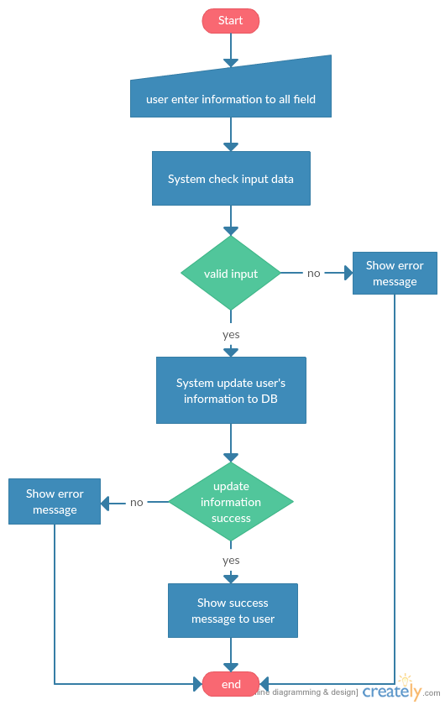

Screen:

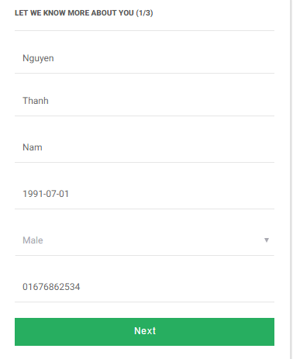

### Enter matching survey

Functional detail:

|  |  |
| --- | --- |
| Name | Enter information |
| Description | User need enter their matching survey |
| Actor | User |
| Pre-condition | - User login success to system, account is active, enter all require information - User enter their matching data, press save button |
| Post-condition | Success: Show success message to user  Fail: Show error message to user |

Workflow:

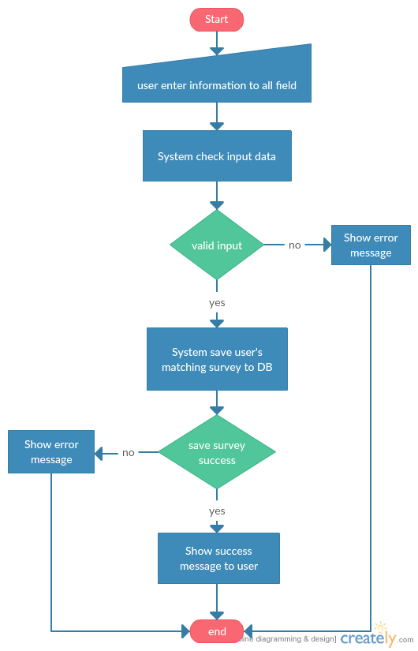

Screen:

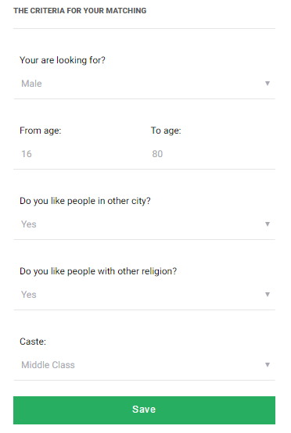

### Upload avatar

Functional detail:

|  |  |
| --- | --- |
| Name | Upload avatar |
| Description | User can upload their avatar |
| Actor | User |
| Pre-condition | - User login success to system, account is active, enter all require information - User choose photo and press save |
| Post-condition | Success: Show success message to user  Fail: Show error message to user |

Workflow:

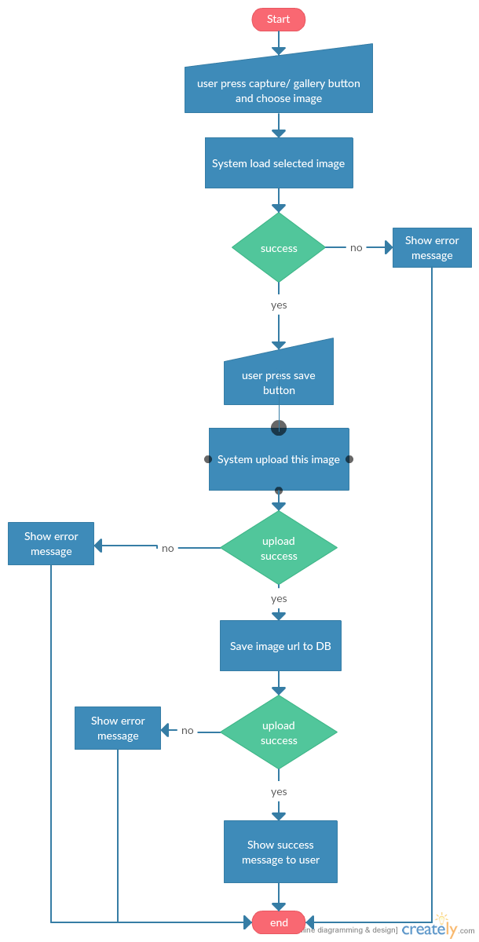

Screen:

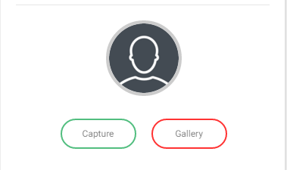

### View avatar

Functional detail:

|  |  |
| --- | --- |
| Name | Upload avatar |
| Description | User can upload their avatar |
| Actor | User |
| Pre-condition | - User login success to system, account is active, enter all require information - User go to profile screen, press on avatar and choose view button |
| Post-condition | Success: Show their avatar to user  Fail: Show error message to user |

Workflow:

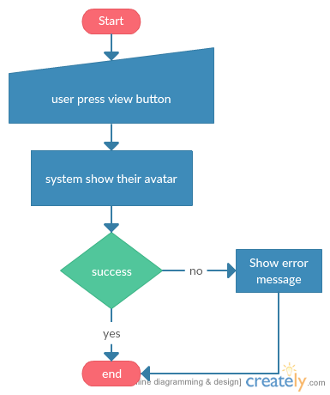

Screen:

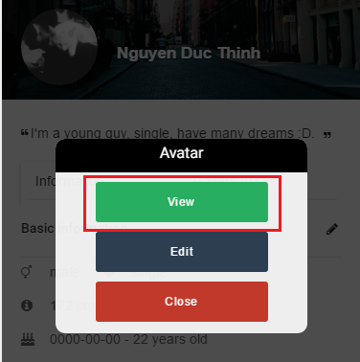

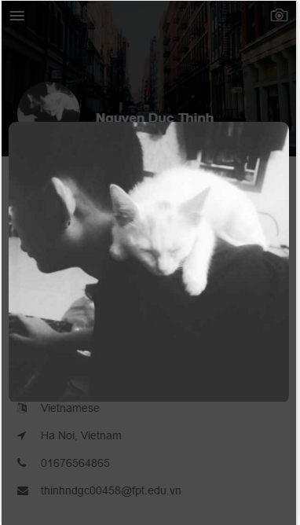

### Edit avatar

Functional detail:

|  |  |
| --- | --- |
| Name | Edit avatar |
| Description | User edit their avatar |
| Actor | User |
| Pre-condition | - User login success to system, account is active, enter all require information - User go to profile screen, press on avatar and choose edit button |
| Post-condition | Success: avatar updated, show success message to user  Fail: Show error message to user |

Workflow:

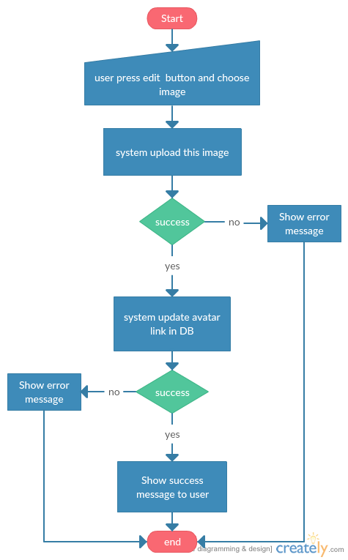

Screen:

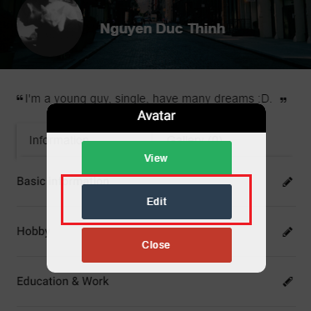

### View cover image

Functional detail:

|  |  |
| --- | --- |
| Name | View cover image |
| Description | User can view their cover image |
| Actor | User |
| Pre-condition | - User login success to system, account is active, enter all require information - User go to profile screen, press on camera button and press view |
| Post-condition | Success: cover image show to user  Fail: Show error message to user |

Workflow:

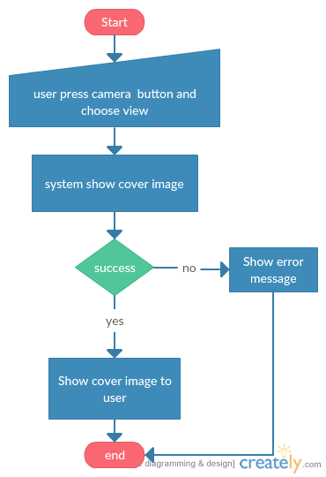

Screen:

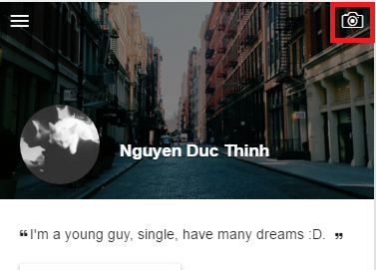 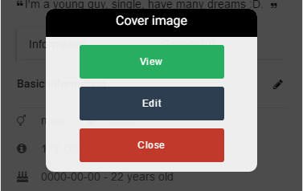

### Edit cover image

Functional detail:

|  |  |
| --- | --- |
| Name | Edit cover image |
| Description | User can edit their cover image |
| Actor | User |
| Pre-condition | - User login success to system, account is active, enter all require information - User go to profile screen, press on camera button and press edit |
| Post-condition | Success: cover image show to user  Fail: Show error message to user |

Workflow:

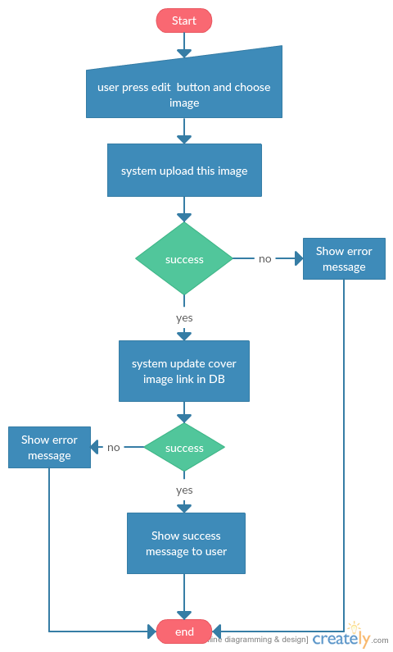

Screen:



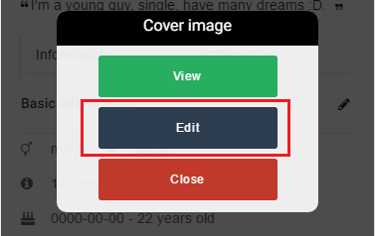

### Upload their image

Functional detail:

|  |  |
| --- | --- |
| Name | Upload their image |
| Description | User can view their image to profile |
| Actor | User |
| Pre-condition | - User login success to system, account is active, enter all require information - User go to profile screen, choose gallery tab and press add button |
| Post-condition | Success: image is upload, show success message to user  Fail: Show error message to user |

### View their image in gallery

Functional detail:

|  |  |
| --- | --- |
| Name | View image in gallery |
| Description | User can view their image uploaded to gallery |
| Actor | User |
| Pre-condition | - User login success to system, account is active, enter all require information - User go to profile screen, gallery button and press on image |
| Post-condition | Success: image show to user  Fail: Show error message to user |

Workflow:

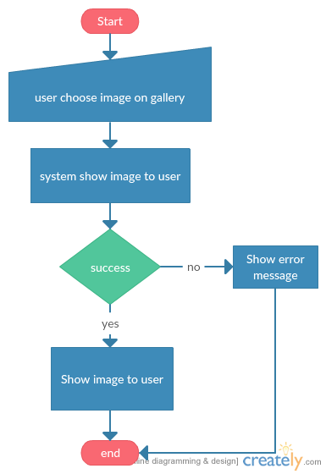

Screen:

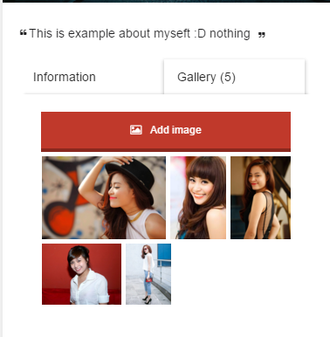

### View profile

Functional detail:

|  |  |
| --- | --- |
| Name | View profile |
| Description | User can view their profile |
| Actor | User |
| Pre-condition | - User login success to system, account is active, enter all require information - User press profile button on menu |
| Post-condition | Success: profile show to user |

Workflow:

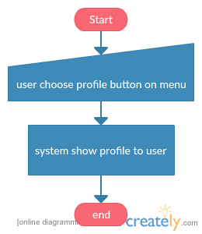

Screen:

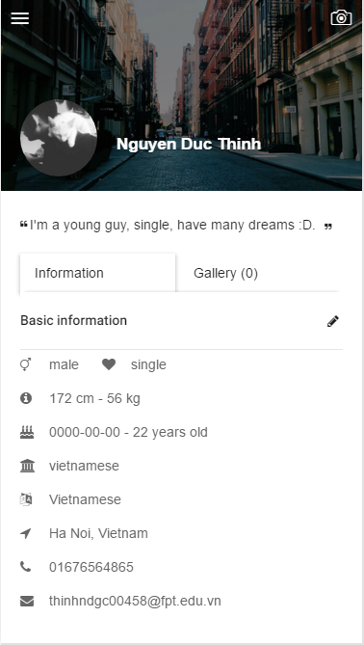

### Edit user information

Functional detail:

|  |  |
| --- | --- |
| Name | Edit user information |
| Description | User can edit their information |
| Actor | User |
| Pre-condition | - User login success to system, account is active, enter all require information - User go to profile screen, press edit button, enter information |
| Post-condition | Success: show success message to user, information updated  Fail: Show error message to user |

Workflow:

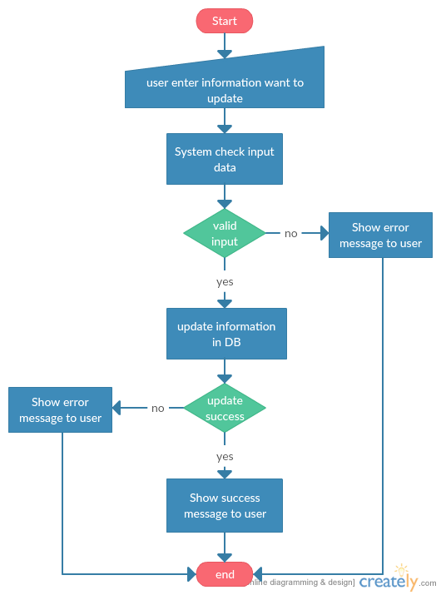

Screen:

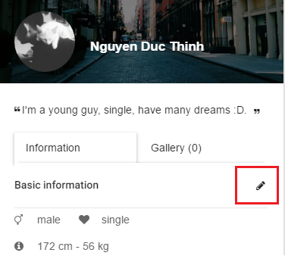

### Edit matching survey

Functional detail:

|  |  |
| --- | --- |
| Name | Edit matching survey |
| Description | User can edit their survey |
| Actor | User |
| Pre-condition | - User login success to system, account is active, enter all require information - User press on survey button on menu |
| Post-condition | Success: show success message to user, survey updated  Fail: Show error message to user |

Workflow:

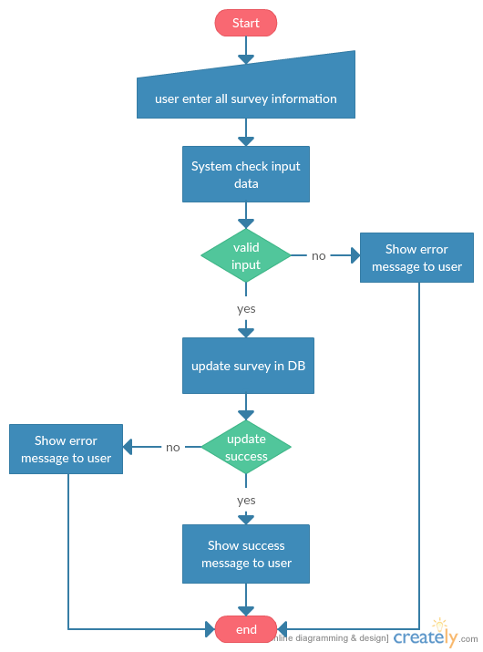

Screen:

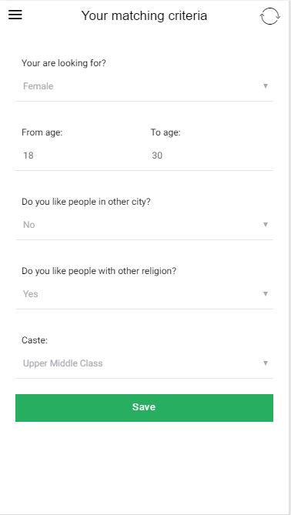

### View matching result

Functional detail:

|  |  |
| --- | --- |
| Name | View matching result |
| Description | User can view their matching result |
| Actor | User |
| Pre-condition | - User login success to system, account is active, enter all require information - User have matching survey, press matching button on menu |
| Post-condition | Success: show result to user  Fail: Show error message to user |

Workflow:

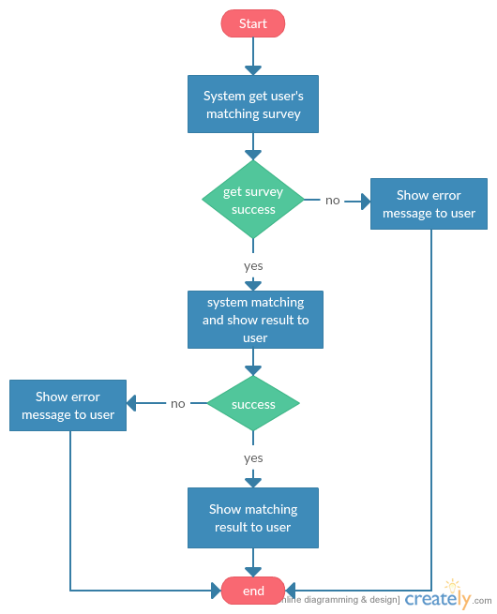

Screen:

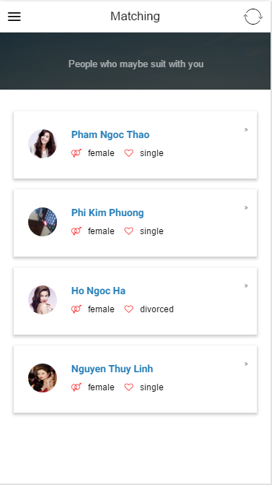

### View other profile

Functional detail:

|  |  |
| --- | --- |
| Name | View user profile |
| Description | User can view profile of other user |
| Actor | User |
| Pre-condition | - User login success to system, account is active, enter all require information - User press name of other user |
| Post-condition | Success: Show other profile of user  Fail: Show error message to user |

Workflow:

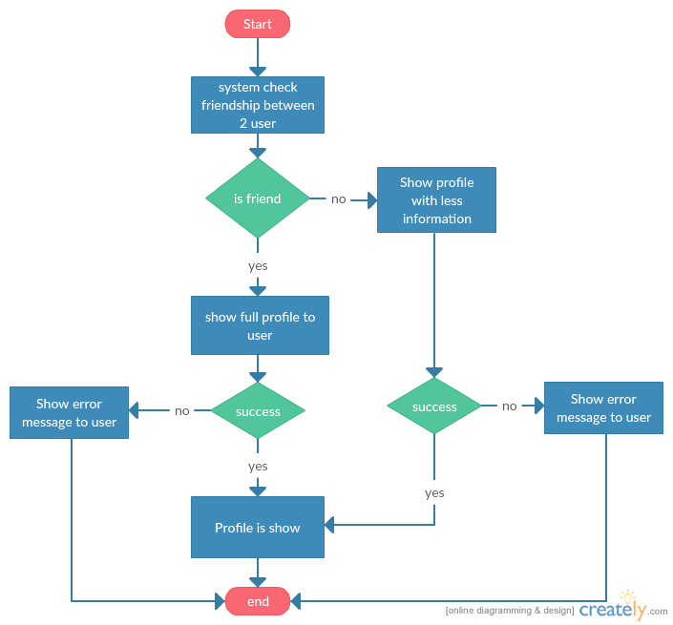

Screen:

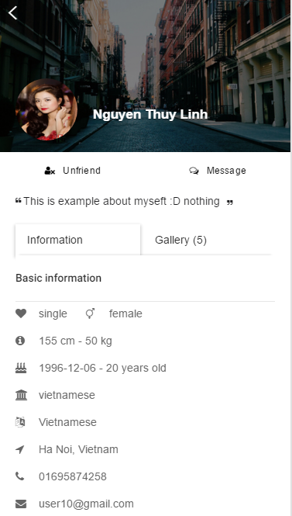

### Send friend request to user

Functional detail:

|  |  |
| --- | --- |
| Name | Send friend request to other user |
| Description | User can send friend request to other user |
| Actor | User |
| Pre-condition | - User login success to system, account is active, enter all require information - User click on add friend button, 2 user aren’t friend |
| Post-condition | Success: show success message to user, request is send  Fail: Show error message to user |

Workflow:

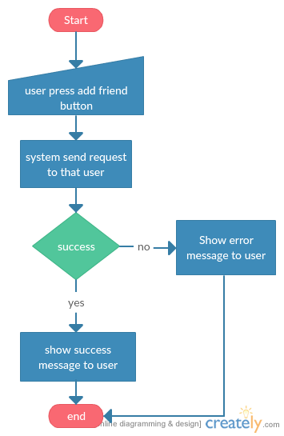

Screen:

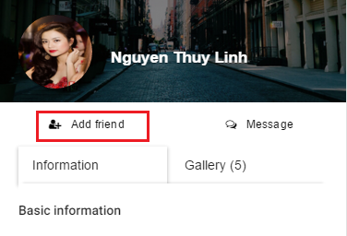

### View friend request list

Functional detail:

|  |  |
| --- | --- |
| Name | View friend request list |
| Description | User can view all friend request to him/her |
| Actor | User |
| Pre-condition | - User login success to system, account is active, enter all require information - User click on request list on friend menu |
| Post-condition | Success: show friend request list to user  Fail: Show error message to user |

Workflow:

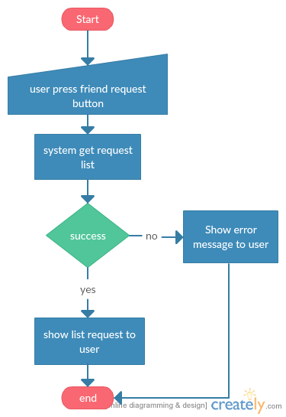

Screen:

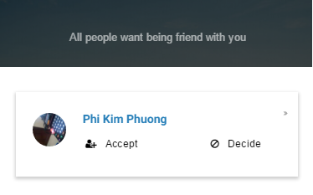

### Cancel friend request

Functional detail:

|  |  |
| --- | --- |
| Name | View friend request list |
| Description | User can cancel their friend request |
| Actor | User |
| Pre-condition | - User login success to system, account is active, enter all require information - User click on cancel button and confirm |
| Post-condition | Success: request is cancel  Fail: Show error message to user |

Workflow:

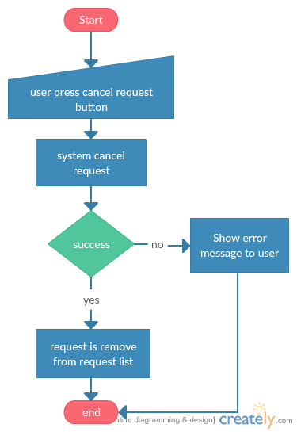

Screen:

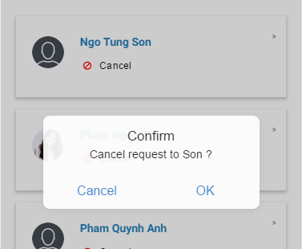

### View list friend request of user

Functional detail:

|  |  |
| --- | --- |
| Name | View list friend request of user |
| Description | User can view all their request to other oser |
| Actor | User |
| Pre-condition | - User login success to system, account is active, enter all require information - User click on list request on friend menu |
| Post-condition | Success: show request list to user  Fail: Show error message to user |

Workflow:

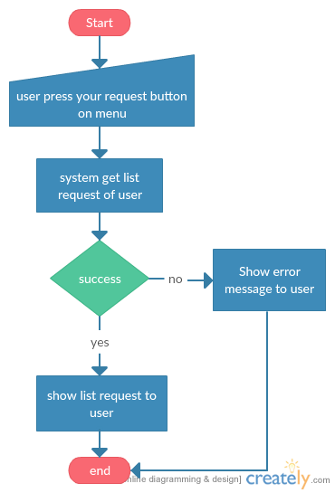

Screen:

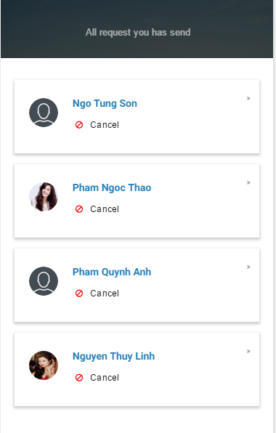

### Decide friend request

Functional detail:

|  |  |
| --- | --- |
| Name | Decide friend request |
| Description | User can decide request from other user |
| Actor | User |
| Pre-condition | - User login success to system, account is active, enter all require information - User click decide button and confirm |
| Post-condition | Success: request is removed  Fail: Show error message to user |

Workflow:

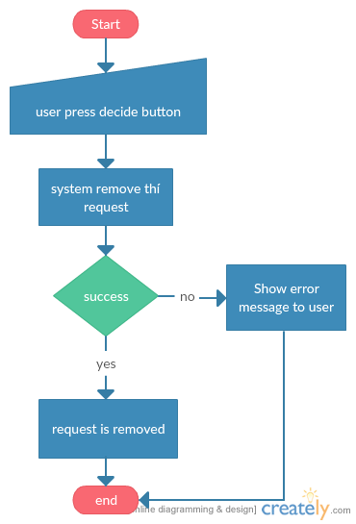

Screen:

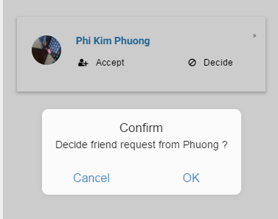

### Accept friend request

Functional detail:

|  |  |
| --- | --- |
| Name | Accept friend request |
| Description | User can accept request from other user |
| Actor | User |
| Pre-condition | - User login success to system, account is active, enter all require information - User press accept button |
| Post-condition | Success: 2 users is friend  Fail: Show error message to user |

Workflow;

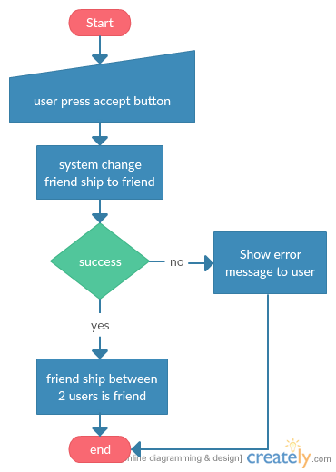

Screen:

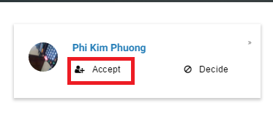

### Unfriend

Functional detail:

|  |  |
| --- | --- |
| Name | Unfriend |
| Description | User can unfriend other user |
| Actor | User |
| Pre-condition | - User login success to system, account is active, enter all require information - User press unfriend button and confirm |
| Post-condition | Success: friendship between 2 users is removed  Fail: Show error message to user |

Workflow:

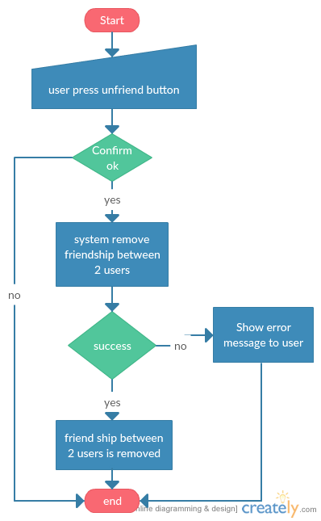

Screen:

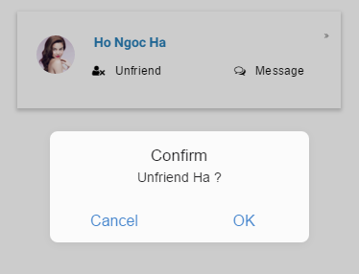

### View friend list

Functional detail:

|  |  |
| --- | --- |
| Name | View friend list |
| Description | User can unfriend other user |
| Actor | User |
| Pre-condition | - User login success to system, account is active, enter all require information - User press unfriend button and confirm |
| Post-condition | Success: friendship between 2 users is removed  Fail: Show error message to user |

Workflow:

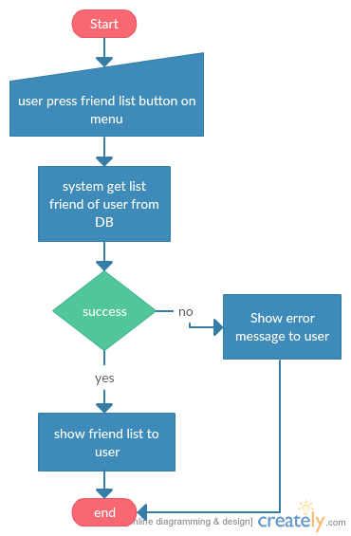

Screen:

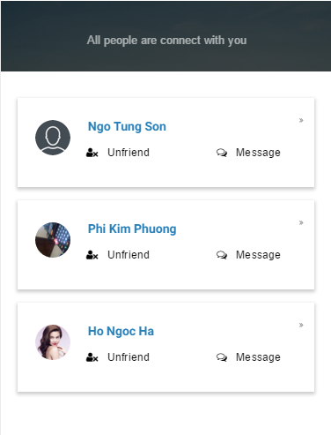

### Search

Functional detail:

|  |  |
| --- | --- |
| Name | Search |
| Description | User can search for other user |
| Actor | User |
| Pre-condition | - User login success to system, account is active, enter all require information - User enter information want to search and press search button |
| Post-condition | Success: Show list result to user  Fail: Show error message to user |

Workflow:

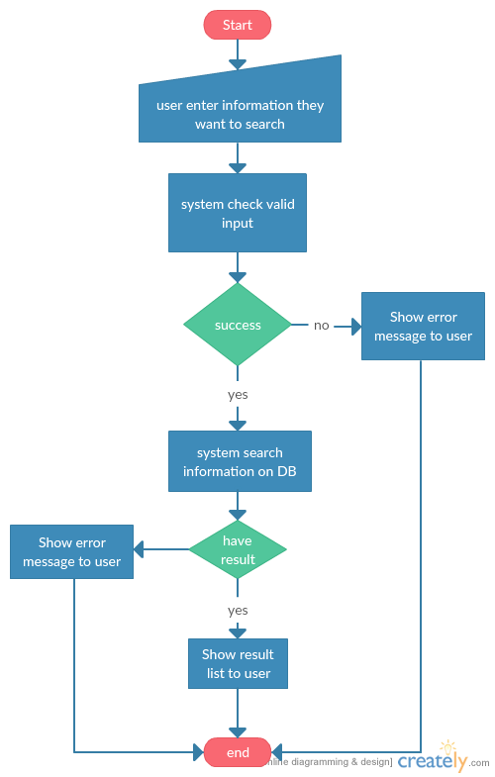

Screen:

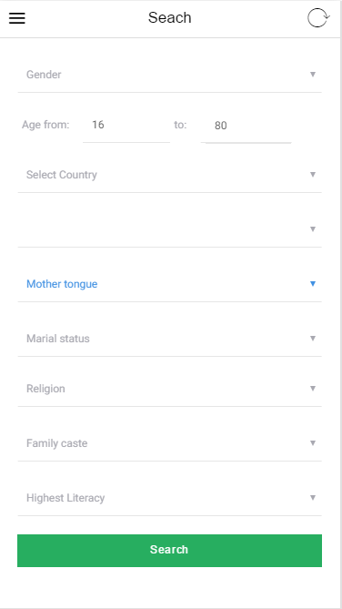

### View gallery of other user

Functional detail:

|  |  |
| --- | --- |
| Name | View other user’s gallery |
| Description | User can view photos of other user if 2 users is friend |
| Actor | User |
| Pre-condition | - User login success to system, account is active, enter all require information - 2 User are friend |
| Post-condition | Success: Show gallery to user  Fail: Show error message to user |

Workflow:

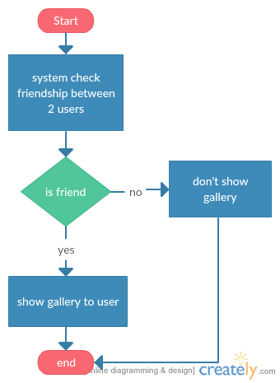

Screen:

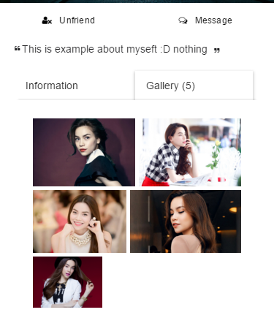

### Chat

Functional detail:

|  |  |
| --- | --- |
| Name | Chat |
| Description | User can send message to other user |
| Actor | User |
| Pre-condition | - User login success to system, account is active, enter all require information - 2 User are friend |
| Post-condition | Success: Send message to other user  Fail: Show error message to user |

Workflow:

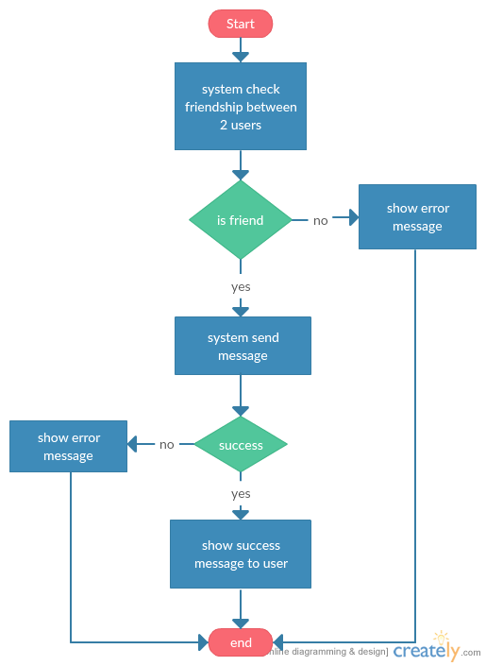

Screen:

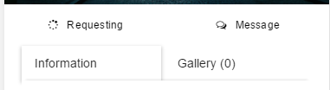

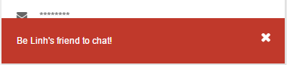

### Logout

Functional detail:

|  |  |
| --- | --- |
| Name | Logout |
| Description | User can logout |
| Actor | User |
| Pre-condition | - User login success to system, account is active, enter all require information - User press logout button |
| Post-condition | Success: User is logout  Fail: Show error message to user |

Workflow:

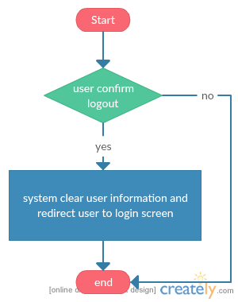

Screen:

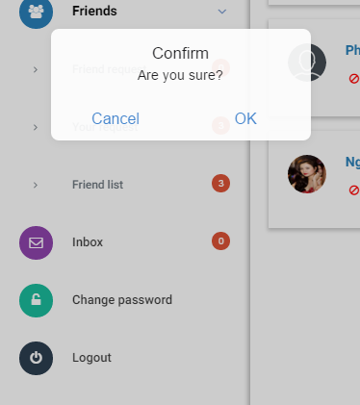

# Development of………..

Based on your designs now discuss how you implemented then

Did you have to make changes?

Were there any technical problems you hadn’t foreseen?

What advanced coding did you create / adapt?

Put relevant snippets in the text, refer to more complex examples in the appendix

Explain what and why you did what you did.

Don’t give lots of boring detail explain the skilful decisions and techniques you used and implemented

Discuss any interim testing you did.

Refer back to the research you did.

# Testing and Evaluation

## Introduction

The section will take a looks into testing and evaluation the Tiny matrimony system against the defined requirements in the requirement analysis part to ensure it is meet with requirement.

## Function Testing

Function testing is a very important part in the process of software development. It ensures the system is working correctly through test all functions.

### User function

|  |  |  |  |
| --- | --- | --- | --- |
| # | **Function** | **Expected Result** | **Actual Result** |
| 1 | User register | User success registered their account | As Expected |
| 2 | Reset password | Created a new password and sent an email to the user. | As Expected |
| 3 | Change password | User change their password success | As Expected |
| 4 | User login | User logged in to system | As Expected |
| 5 | Active account | User activate their account success | As Expected |
| 6 | Enter require information | Users enter their information and save to DB success | As Expected |
| 7 | Get new active code | Create and send new activation code to user's email success | As Expected |
| 8 | Enter matching survey | User enter their survey and save to DB success | As Expected |
| 9 | Upload avatar | User upload their avatar success | As Expected |
| 10 | View avatar | User view their avatar success | As Expected |
| 11 | Edit avatar | Avatar edited | As Expected |
| 12 | View cover image | User view their cover image success | As Expected |
| 13 | Edit cover image | Cover image edited | As Expected |
| 14 | Upload their image | User uploaded their image to gallery | As Expected |
| 15 | View profile | User viewed their profile | As Expected |
| 16 | View their image in user gallery | User view their gallery success | As Expected |
| 17 | Edit user information | Information edited, save in DB success | As Expected |
| 18 | Edit matching survey | Edit matching survey success | As Expected |
| 19 | View matching result | Show list user suit for user | As Expected |
| 20 | View other profile | - View full other profile if users is friend - If not friend user only can see a little information | As Expected |
| 21 | Send friend request | Send friend request to other user success | As Expected |
| 22 | View friend request list | Show list friend request to user success | As Expected |
| 23 | Cancel friend request | Cancel friend request success | As Expected |
| 24 | View list friend request of user | Show list request of user success | As Expected |
| 25 | Decide friend request | Decide success request from other user | As Expected |
| 26 | Accept friend request | Accepted friend request from other user | As Expected |
| 27 | Unfriend | Unfriend other user success | As Expected |
| 28 | View friend list | Show friend list of user success | As Expected |
| 29 | Search | - Can search by multi criteria - Show result success | As Expected |
| 30 | View gallery of other user | - Can’t view if 2 user aren’t friend - View gallery success if is friend | As Expected |
| 31 | Chat |  |  |
| 32 | Logout | User logged out | As Expected |

### System function

|  |  |  |  |
| --- | --- | --- | --- |
| # | **Function** | **Expected Result** | **Actual Result** |
| 1 | Send email with activation code to user’s email after register success | Send email with activation code success | As Expected |
| 2 | Send email with new password to user when user request new password | Send email with new password success | As Expected |
| 3 | Matching user with other user who suit with this user | Matching and respond result to user success | As Expected |
| 4 | Check friendship between 2 users to give right permission when user want to see profile of other user | Checking and give right permission | As Expected |

## UI testing

### Responsive testing:

- Galaxy nexus 5x – Portrait:

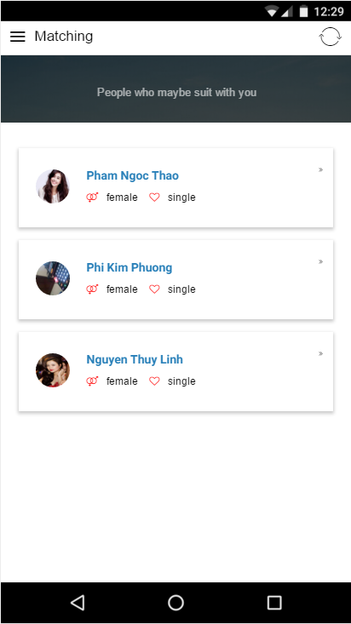

- Galaxy nexus 5x – Landscape:

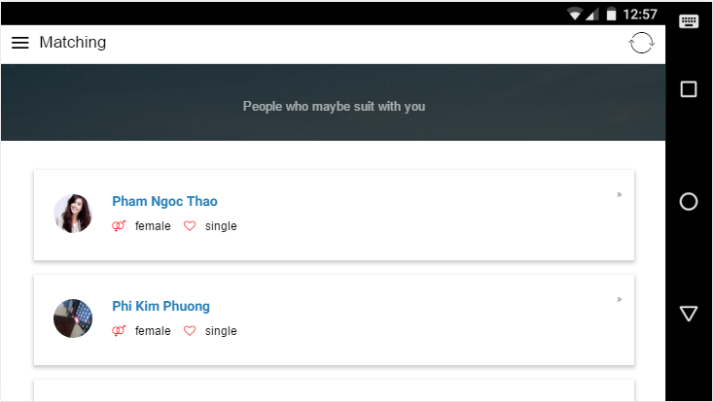

- IPhone 6 plus – Landscape:

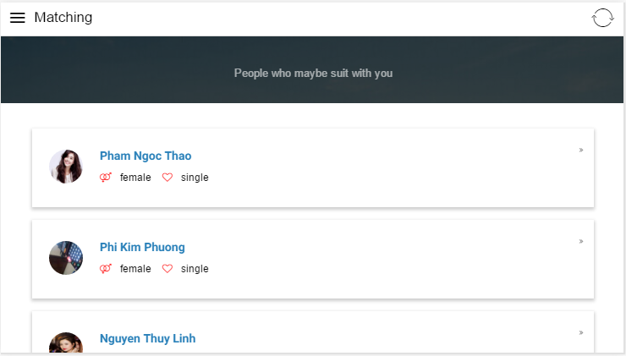

- IPad:

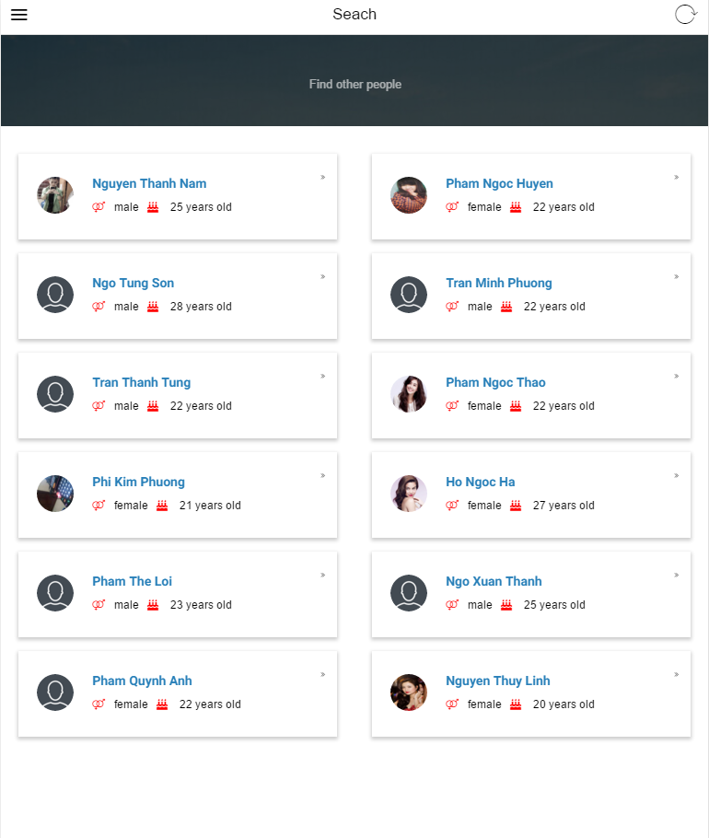

### Componence Testing

|  |  |  |  |
| --- | --- | --- | --- |
| # | **Componence** | **Expected Result** | **Actual Result** |
| 1 | Input field - type: text | Responsive and good respond in use. | As Expected |
|  | Input field - type: number | Responsive and good respond in use. | As Expected |
|  | Select box | Responsive and good respond in use. | As Expected |
|  | Button | Responsive and good respond in use. | As Expected |
|  | Menu | Responsive and good respond in use. | As Expected |
|  | Menu button | Responsive and good respond in use. | Sometimes doesn’t respond |
|  | Tabs | Responsive and good respond in use. | As Expected |
|  | Alert message | Responsive and good respond in use. | As Expected |

## Evaluation

Functional:

Design:

This software is a hybrid application, using Onsen UI framework to build the interfaces. Onsen UI supports component similar with native application and can be compatible with multiple device types with different screen sizes. The software interface was designed very easy for users to use, these functions of the system is divided into separate menus, the screen does not contain too much information or buttons help users quickly grasp the information and the main function, also avoid redundancies information. About the colour, the application is designed with light tones, easy to see, do not use too many colours in the design, the colours are coordinated in a reasonable manner to make users feel comfortable when look at the interface. Regarding to effects, the framework supports page transition effects, display notifications effects and effects when press the button like a native application, these effect are well represented, isn't have too much delay, users will feel comfortable with no sense of this is a web view. The application uses a single font, avoid cluttered feel for the user. Overall, applications have rational interface, easy to see and easy to use for all users, suitable for a mobile application.

Database:

Database of system implements from the ERD, the designed tables can store the information need for the system and the user's information. Some store procedure was used to avoid using too much complex queries. Overall current database can meet all the existing functionality of the system, but to grow up system larger, the need to optimize the database further.

Security:

Users need an account to login and use the system. Account password is encrypted using MD5 Hashing algorithm, which is one-way encryption algorithm and inability to decompile, helps protect users' accounts better. Each time the user requests a new password for their account, the system will only send information about the new password to the email address user has registered on the system, no one can get new passwords except they get the user's email account. Furthermore only user can change their personal information. When changing the account's password, to prevent someone tries to change the account password by guessing words , after enter the wrong password three times, the system will auto log out the account from the device. Overall this system security is quite good with the basic security measures are often used, no advanced security measures are applied in this system.

Testing:

## Future Enhancements

After development and testing, the system has meet the requirements set out, but still can improve the system by adding new functionalities much better support for users, improve further the performance of the system. These functions necessary to develop in the future may mention as:

Update notifications on the phone screen every time there new request, or someone sends a friend request to the user. This feature will help users always fully update the information, have better interact with the system.

Develop a function that allows users to save people they love, helping users to quickly interact with the people they love is no need to go through multiple steps to search.

Allows users to enter information further more variety, such as more additional information hobby, the conception of life, etc. Along with that also allows users to search based on more information. And this function will help people who use this system easier understand each other.

And features needed to develop in the future is to improve the matching function of system. Currently matching functions only based on the user's survey, from that builds the SQL statements to find on the system database and provide the appropriate people for user. Such systems can’t collect and analyse data to give users the results. In the future, if desired grow up this systems larger , there should have a smart mechanism for matching, system can auto collect and analysis user data, also using algorithms and data mining to automatically provide list of people most suitable. This feature will help provide higher efficiency, improve the quality of matching result, users will also more pleased with the system and the number of people who want to use the system will increase.

## Summary

After the testing process and the evaluation shows that Tiny Matrimony System was working normally, meet with the requirements set out in Requirement Analysis. But there are still a few errors of interface, namely the menu for the friends sometimes unresponsive when users interact.

## Conclusion

Summarise your key thoughts about the project.

References

References should be ordered alphabetically by the name of the author (or, if there is more than one, the name of the first author. The Harvard system is used. Each reference should state the author’s name and initials, date (in parentheses), title, publisher and place of issue (if known) e.g. Seber G.A.F. (2003), Multivariate Observations, John Wiley, New York.

If the reference is to a journal or to a conference proceedings article, then the journal title, volume, number and page numbers should be added, e.g. Parna s D.L. et al (2001), Evaluation of Safety Critical Software, CACM, Vol. 33, No.6, pp. 636-651.

Using internet sources you should ad the word “online” in brackets after the title of the work, plus the URL after the name of the publisher.

1. Project Proposal

Have several appendices (A,B,C…). These should include detailed and technical documentation such as table of results, diagrams, program source code, etc, which are essential parts of the project but not directly a part of the main discussion in the report. All contents of appendices should be exclusively, products of the student’s own work.

Other materials used during the project work (such as information from user manuals, interview notes, etc), which it is necessary to include, should if possible be summarized to only a few pages before entering into the appendix. Original copies of such material should be kept by the student and may be required to be produced as supporting evidence of their work.

Examples of key coding may be provided in an Appendix but generally it should be uploaded via teachmat or on the P drive with its associated software.

1. Ertwt

Dfhkgfdg

2. ???????
3. ???????